Crochet Creature
Dave the Dog
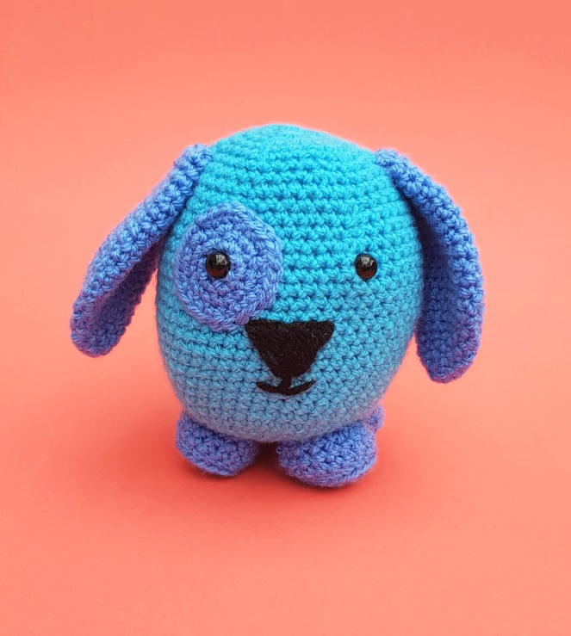
Designed By: Donna Wilkins, The Crochet Craft Co.

Dated: January 2018

For more patterns and information, please visit me on:
www.thecrochetcraftco.co.uk
www.facebook.com/crochetcraftco
www.etsy.com/shop/thecrochetcraftco
crochetcraftco@outlook.com

Hello, thank you for purchasing my Crochet Creature, Dave the Dog. Dave is just the right size for little hands. He has lots more friends available too. Visit www.thecrochetcraftco.co.uk for more info.

Size: 5 inches.

Materials:
hook: US G (4.00 mm)
yarn: DK acrylic yarn. I used Sirdar Hayfield Bonus DK but any DK can be used.
112 metres (40 grams) of Colour A (Shade: Turquoise) for main body.
112 metres (40 grams) of Colour B (Shade: Bluebell) for patch, ears, feet and tail.
stitch marker
tapestry needle
safety eyes 9mm (embroidered eyes can be made as an alternative)
toy stuffing
black yarn – small amount for nose

Gauge: This pattern does not require a specific gauge.

Skill Level: Easy

Notes: Pattern is worked in continuous rounds; do not join at the end of rounds.

Abbreviations used: (US terms)
mc: magic circle
ch: chain stitch
sk: skip
sl st: slip stitch
st(s): stitch(es)
yo: yarn over
sc: single crochet
sc2tog: single crochet 2 stitches together
blo: back loop

Stitch Explanation:

mc make a loop with the yarn, leaving a tail around 10cm long. Make sure the tail end is on the left hand side. Insert your hook into the loop, from front to back. Wrap the working yarn around the hook and pull the yarn through the loop, chain 1. Your first round of stitches will then be worked into the loop. Once you’ve worked the number of stitches you need into the loop, simply pull the tail end of the yarn to draw up and close the loop – magic! (An alternative to the mc is to chain 3 and join with a sl st to first chain, then work first round of stitches into loop created.)

sl st Insert hook into stitch indicated, wrap yarn over hook, draw the yarn through the chain and the loop in one movement.

sc Insert your hook into the stitch or space indicated, yarn over and pull up a loop. (You should have two loops on your hook). Yarn over and draw through both of the loops on your hook

sc2tog Insert hook in next stitch, draw up a loop, (two loops on hook), insert hook in next stitch, draw up a loop (3 loops on hook), YO and draw through all 3 loops.

blo to crochet in the back loop of a stitch, insert your crochet hook underneath the back loop only of the stitch (furthest away from you) and make the stitch as indicated in your pattern.

PATTERN INSTRUCTIONS

Eye Patch (with colour B)

Round 1: mc, 6sc in circle (6)
Round 2: 2sc in each st (12)
Round 3: *2sc in first st, sc in next*, repeat between ** to end of round (18)
Round 4: *2sc in first st, sc in next 2 sts*, repeat between ** to end of round (24)

Sl st into first stitch of next round to finish off round neatly. Fasten off and leave long tail. Attach one safety eye to middle of patch. Leave the other safety eye to attach direct to the main head/body of the dog.

Ears (Make two) (with colour B)

Round 1: mc, 4sc in circle (4)
Round 2: 2sc in each st (8)
Round 3: *2sc in first st, sc in next 3 sts*, repeat between ** to end of round (10)
Round 4: *2sc in first st, sc in next 4 sts*, repeat between ** to end of round (12)
Round 5: *2sc in first st, sc in next 5 sts*, repeat between ** to end of round (14)
Round 6: *2sc in first st, sc in next 6 sts*, repeat between ** to end of round (16)
Round 7: *2sc in first st, sc in next 7 sts*, repeat between ** to end of round (18)
Round 8: *2sc in first st, sc in next 8 sts*, repeat between ** to end of round (20)
Round 9: *2sc in first st, sc in next 9 sts*, repeat between ** to end of round (22)
Round 10–14: sc in each st (22)
Round 15: *sc2tog, sc in next 9 sts*, repeat between ** to end of round (20)
Round 16: sc in each st (20)
Round 17: *sc2tog, sc in next 8 sts*, repeat between ** to end of round (18)
Round 18: sc in each st (18)
Round 19: *sc2tog, sc in next 7 sts*, repeat between ** to end of round (16)
Round 20: *sc2tog, sc in next 6 sts*, repeat between ** to end of round (14)
Round 21: *sc2tog, sc in next 5 sts*, repeat between ** to end of round (12)
Round 22: *sc2tog, sc in next 4 sts*, repeat between ** to end of round (10)

Sl st into first stitch of next round to finish off round neatly. Fasten off and leave long tail.

Feet (make 4) (with colour B)

Round 1: mc, 6sc in circle (6)
Round 2: 2sc in each st (12)
Round 3: *2sc in first st, sc in next*, repeat between ** to end of round (18)
Round 4: sc in each blo (18)
Round 5-6 sc in each st (18)
Round 7: *sc2tog, sc in next 4 st*, repeat between ** to end of round (15)

Sl st into first stitch of next round to finish off round neatly. Fasten off and leave long tail.

Tail (with colour B)

Round 1: mc, 3sc in circle (3)
Round 2: 2sc in first st, sc to end of round (4)
Round 3: 2sc in first st, sc to end of round (5)
Round 4: 2sc in first st, sc to end of round (6)
Round 5: 2sc in first st, sc to end of round (7)
Round 6: 2sc in first st, sc to end of round (8)
Round 7: 2sc in first st, sc to end of round (9)
Round 8: 2sc in first st, sc to end of round (10)
Round 9: 2sc in first st, sc to end of round (11)
Round 10: 2sc in first st, sc to end of round (12)

Sl st into first stitch of next round to finish off round neatly. Fasten off and leave long tail.

Head and Body (with colour A)

Round 1: mc, 6sc in circle (6)
Round 2: 2sc in each st (12)
Round 3: *2sc in first st, sc in next*, repeat between ** to end of round (18)
Round 4: *2sc in first st, sc in next 2 sts*, repeat between ** to end of round (24)
Round 5: *2sc in first st, sc in next 3 sts*, repeat between ** to end of round (30)
Round 6: *2sc in first st, sc in next 4 sts*, repeat between ** to end of round (36)
Round 7: *2sc in first st, sc in next 5 sts*, repeat between ** to end of round (42)
Round 8: *2sc in first st, sc in next 6 sts*, repeat between ** to end of round (48)
Round 9 –11: sc in each st (48)
Round 12: *2sc in first st, sc in next 7 sts*, repeat between ** to end of round (54)
Round 13–23: sc in each st (54)
Round 24: *sc2tog, sc in next 7 sts*, repeat between ** to end of round (48)
Round 25–26: sc in each st (48)
Round 27: *sc2tog, sc in next 6 sts*, repeat between ** to end of round (42)
Round 28: sc in each st (42)
Round 29: *sc2tog, sc in next 5 sts*, repeat between ** to end of round (36)
Round 30: sc in each st (36)

At this point, secure eye patch and safety eyes between round 22 and 23, 11 stitches apart.

Round 31: *sc2tog, sc in next 4 sts*, repeat between ** to end of round (30)
Round 32: *sc2tog, sc in next 3 sts*, repeat between ** to end of round (24)
Round 33: *sc2tog, sc in next 2 sts*, repeat between ** to end of round (18)
Round 34: *sc2tog, sc in next*, repeat between ** to end of round (12)
Round 35: sc2tog to end of round (6)

Fasten off, fill with toy stuffing and close hole, weaving in end with tapestry needle.

Finishing

Nose - Using black yarn, embroider nose & mouth between safety eyes, five stitches wide, 4 rounds in length, using picture as a guide.

Ears - Attach to side of head at round 30-31
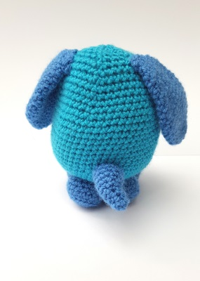
Feet – Attach all four to bottom of body (between rounds 2 and 7 of main body).

Tail - Attach to back of dog (between round 14-16 of main body).

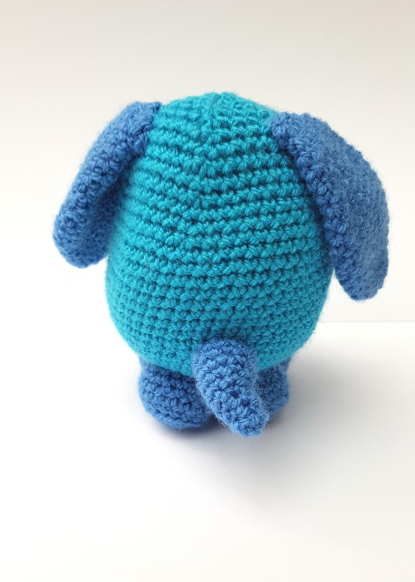

Dave the Dog is now ready. Enjoy!!

