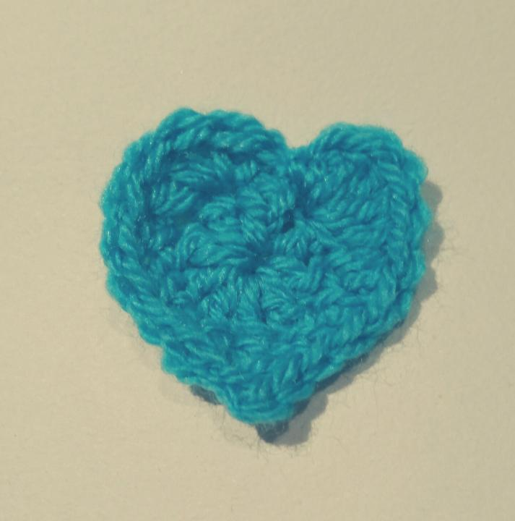
BASIC CROCHET HEART
Start with a magic ring (alternatively ch3 and join with sl st).
Round 1: 9 dc into ring, sl st into top of first dc.
Round 2: 5 dc into 1st st, 1dc into next stitch, 1 hdc into next stitch, 1 sc into next stitch,
Now we will work on the pointy bottom of the heart:
In same stitch: 1 dc, picot point (ch 2, insert hook in 2nd ch from hook, yo, pull through all loops on hook) , 1 dc.
Working up the other side of the heart;
1 sc in next st, 1 hdc in next st, 1 dc in next st, 5 dc in next st, sl st to centre
Fasten off and weave in ends.

FILLED CROCHET HEART
Make Two
Start with a magic ring.
Round 1: 6sc into ring (6)
Round 2: 2sc into each st (12)
Round 3-4: sc around (12)
Round 5: Join two together with sl st, sc around (24)
Round 6: sc around (24)
Round 7: 2sctog in 1st st, sc around (22)
Round 8: 2sctog in 1st st, sc around (20)
Round 9: 2sctog in 1st st, sc around (18)
Round 10: 2sctog in 1st st, sc around (16)
Round 11: sc around (16)
Round 12: *2sctog in next st, sc in next st* repeat between ** to end (11)
Round 13: 2sctog in 1st st, sc around (10)
Round 13: *2sctog in 1st st in next 4*, repeat between ** (8)
Round 14: 2sctog, around to end (4)
Fasten off, stuff with a little toy stuffing and sew closed.

